CPS Theory Assignment 1
Group Members:
- Arham Hussain (22k-4080)
- Hateem Siddiqui (22k-8701)
- Yasir Chandio(22k-4089)
- Aarib Ahmed(22k-4004)

Q1 Answer:
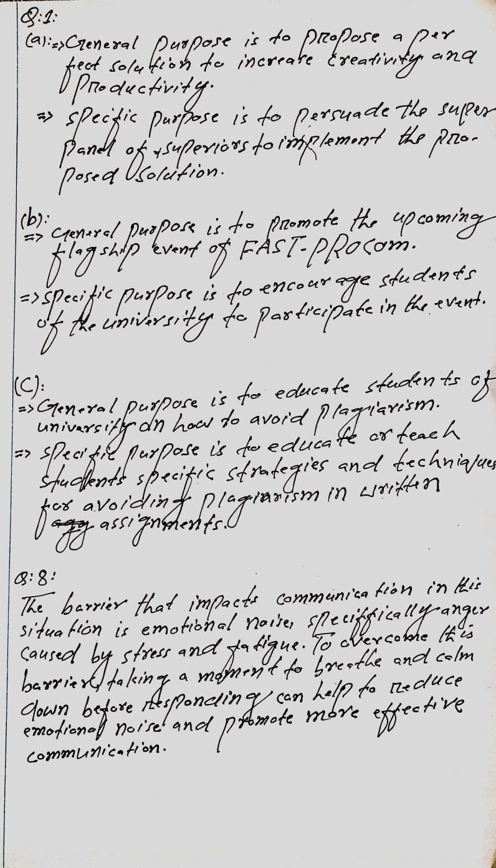

Q2 Answer:
- First Strategy would be using pictures, charts, diagrams etc. to explain points more effectively.
- Another would be making use of special effects and animation to make the presentation more interesting and appealing.
Color scheme: Light Colors for e.g., Blue (Will make the presentation simple and easy to understand).
Q3. State 3 rules for making efficient slides. [3]
ANS: 1- Select a particular font size and type. Use it with consistency throughout the slides.
- Do not overload with information on a slide. Use more slides than to fill up a single slide with too much text.
- Use first 2-3 slides to introduce a topic and giving an outline of the presentation.

Q4:
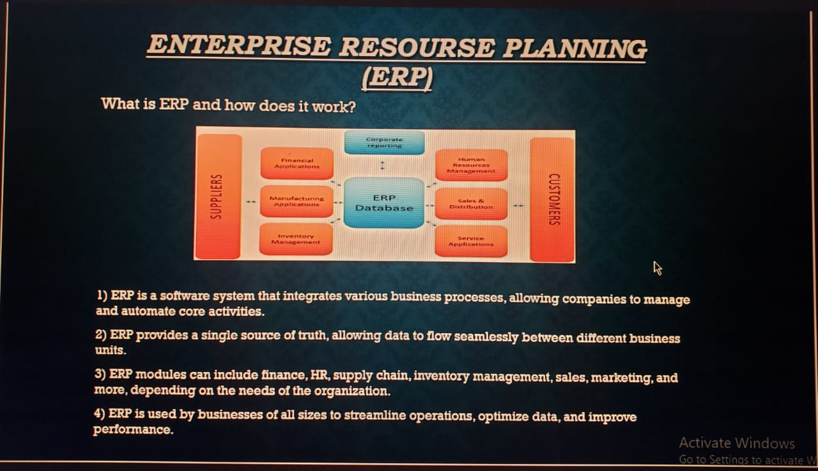


Qs # 5

State 2 ways in which a presenter can use his/her voice effectively for public speaking.

Ans # 5

- By varying the volume of his/her voice, for example raising their voice to lay emphasis on an important point or lowering their voice to create a sense of seriousness.
- Varying their pace and utilizing strategic pauses. Speaking too quickly may make it difficult for the audience to follow along while speaking too slowly becomes boring and tedious for the audience.

Qs # 6

For a formal presentation, what kind of non-verbal communication should a
presenter use. Explain with reference to the use of eyes, posture, and artifacts. Give
only two strategies for each type of non-verbal behavior mentioned here.

Ans # 6

Eyes :- The presenter should maintain eye-contact with the audience while speaking to the audience in order to develop a sense of connection and trust.

Posture :- The presenter should use hand gestures to create a sense of engagement with the audience. Standing up straight is also important in order to look more confident and convey a sense of professionalism.

Artifacts :- Using visual aids such as props or power point slides may make it easier for the audience to grasp complex information. A physical model or demonstration will make the presentation more interesting and add variety.

Qs # 7

An instructor is lively and joking in a class in which students come prepared and
always do more than the assigned work. The same instructor is strict and unyielding
in a class that tries to slide by with minimal work and comes without having read
assignments. Although this is the same instructor, the communication behavior is
different. Discuss the following:

i. The teacher may teach well in which class and why? [2]
ii. Who is responsible for the teacher’s strict and unyielding attitude in another
class? Give reasons for your answer. [2]
iii. What do you learn about the importance of feedback from this scenario? [2]

Ans # 7
- The teacher may teach well in the class in which the students come prepared as the teachers lively attitude will lead to an engaged and positive class environment where the students will be eager to participate and learn. The students positive response will encourage the teacher to put in even more effort.
- The students are responsible for the teacher’s strict and unyielding attitude as they are doing only the bare minimum and not reading their assignments. The teacher feels the need to be strict in order to motivate the students to take the class more seriously and put in more efforts.
- This scenario shows that the teachers attitude and teaching style is influenced by the response/feedback they get from their students. It also shows that the teacher’s behavior can influence the students as well. Feedback is important to create a positive and productive learning environment for both the teacher and the students. It would benefit both the teacher and the students to provide regular feedback on what is working well and what’s not working well in order to improve performance and reach their learning goals.

Q8:

